***REPUBLIC OF CAMEROON***

***PEACE - WORK – FATHERLAND***

***MINISTRY OF HIGHER EDUCATION***

**REPUBLIQUE DU CAMEROUN**

***PAIX – TRAVAIL – PATRIE***

**MINISTERE DE L’ENSEIGNEMENT SUPERIEUR**

**REPUBLIQUE DU CAMEROUN**

***PAIX – TRAVAIL – PATRIE***

**MINISTERE DE L’ENSEIGNEMENT SUPERIEUR**

**REPUBLIQUE DU CAMEROUN**

***PAIX – TRAVAIL – PATRIE***

**MINISTERE DE L’ENSEIGNEMENT SUPERIEUR**

**REPUBLIQUE DU CAMEROUN**

***PAIX – TRAVAIL – PATRIE***

**MINISTERE DE L’ENSEIGNEMENT SUPERIEUR**

**REPUBLIQUE DU CAMEROUN**

***PAIX – TRAVAIL – PATRIE***

**MINISTERE DE L’ENSEIGNEMENT SUPERIEUR**

**REPUBLIQUE DU CAMEROUN**

***PAIX – TRAVAIL – PATRIE***

**MINISTERE DE L’ENSEIGNEMENT SUPERIEUR**

**REPUBLIQUE DU CAMEROUN**

***PAIX – TRAVAIL – PATRIE***

**MINISTERE DE L’ENSEIGNEMENT SUPERIEUR**

**REPUBLIQUE DU CAMEROUN**

***PAIX – TRAVAIL – PATRIE***

**MINISTERE DE L’ENSEIGNEMENT SUPERIEUR**

**REPUBLIQUE DU CAMEROUN**

***PAIX – TRAVAIL – PATRIE***

**MINISTERE DE L’ENSEIGNEMENT SUPERIEUR**

**REPUBLIQUE DU CAMEROUN**

***PAIX – TRAVAIL – PATRIE***

**MINISTERE DE L’ENSEIGNEMENT SUPERIEUR**

**REPUBLIQUE DU CAMEROUN**

***PAIX – TRAVAIL – PATRIE***

**MINISTERE DE L’ENSEIGNEMENT SUPERIEUR**

**REPUBLIQUE DU CAMEROUN**

***PAIX – TRAVAIL – PATRIE***

**MINISTERE DE L’ENSEIGNEMENT SUPERIEUR**

**REPUBLIQUE DU CAMEROUN**

***PAIX – TRAVAIL – PATRIE***

**MINISTERE DE L’ENSEIGNEMENT SUPERIEUR**

**REPUBLIQUE DU CAMEROUN**

***PAIX – TRAVAIL – PATRIE***

**MINISTERE DE L’ENSEIGNEMENT SUPERIEUR**

**REPUBLIQUE DU CAMEROUN**

***PAIX – TRAVAIL – PATRIE***

**MINISTERE DE L’ENSEIGNEMENT SUPERIEUR**

**REPUBLIQUE DU CAMEROUN**

***PAIX – TRAVAIL – PATRIE***

**MINISTERE DE L’ENSEIGNEMENT SUPERIEUR**

**REPUBLIQUE DU CAMEROUN**

***PAIX – TRAVAIL – PATRIE***

**MINISTERE DE L’ENSEIGNEMENT SUPERIEUR**

**REPUBLIQUE DU CAMEROUN**

***PAIX – TRAVAIL – PATRIE***

**MINISTERE DE L’ENSEIGNEMENT SUPERIEUR**

**REPUBLIQUE DU CAMEROUN**

***PAIX – TRAVAIL – PATRIE***

**MINISTERE DE L’ENSEIGNEMENT SUPERIEUR**

**REPUBLIQUE DU CAMEROUN**

***PAIX – TRAVAIL – PATRIE***

**MINISTERE DE L’ENSEIGNEMENT SUPERIEUR**

**REPUBLIQUE DU CAMEROUN**

***PAIX – TRAVAIL – PATRIE***

**MINISTERE DE L’ENSEIGNEMENT SUPERIEUR**

**REPUBLIQUE DU CAMEROUN**

***PAIX – TRAVAIL – PATRIE***

**MINISTERE DE L’ENSEIGNEMENT SUPERIEUR**

**REPUBLIQUE DU CAMEROUN**

***PAIX – TRAVAIL – PATRIE***

**MINISTERE DE L’ENSEIGNEMENT SUPERIEUR**

**REPUBLIQUE DU CAMEROUN**

***PAIX – TRAVAIL – PATRIE***

**MINISTERE DE L’ENSEIGNEMENT SUPERIEUR**

**REPUBLIQUE DU CAMEROUN**

***PAIX – TRAVAIL – PATRIE***

**MINISTERE DE L’ENSEIGNEMENT SUPERIEUR**

**REPUBLIQUE DU CAMEROUN**

***PAIX – TRAVAIL – PATRIE***

**MINISTERE DE L’ENSEIGNEMENT SUPERIEUR**

**REPUBLIQUE DU CAMEROUN**

***PAIX – TRAVAIL – PATRIE***

**MINISTERE DE L’ENSEIGNEMENT SUPERIEUR**

**REPUBLIQUE DU CAMEROUN**

***PAIX – TRAVAIL – PATRIE***

**MINISTERE DE L’ENSEIGNEMENT SUPERIEUR**

**REPUBLIQUE DU CAMEROUN**

***PAIX – TRAVAIL – PATRIE***

**MINISTERE DE L’ENSEIGNEMENT SUPERIEUR**

**REPUBLIQUE DU CAMEROUN**

***PAIX – TRAVAIL – PATRIE***

**MINISTERE DE L’ENSEIGNEMENT SUPERIEUR**

**REPUBLIQUE DU CAMEROUN**

***PAIX – TRAVAIL – PATRIE***

**MINISTERE DE L’ENSEIGNEMENT SUPERIEUR**

**REPUBLIQUE DU CAMEROUN**

***PAIX – TRAVAIL – PATRIE***

**MINISTERE DE L’ENSEIGNEMENT SUPERIEUR**

**REPUBLIQUE DU CAMEROUN**

***PAIX – TRAVAIL – PATRIE***

**MINISTERE DE L’ENSEIGNEMENT SUPERIEUR**

**REPUBLIQUE DU CAMEROUN**

***PAIX – TRAVAIL – PATRIE***

**MINISTERE DE L’ENSEIGNEMENT SUPERIEUR**

**REPUBLIQUE DU CAMEROUN**

***PAIX – TRAVAIL – PATRIE***

**MINISTERE DE L’ENSEIGNEMENT SUPERIEUR**

**REPUBLIQUE DU CAMEROUN**

***PAIX – TRAVAIL – PATRIE***

**MINISTERE DE L’ENSEIGNEMENT SUPERIEUR**

**REPUBLIQUE DU CAMEROUN**

***PAIX – TRAVAIL – PATRIE***

**MINISTERE DE L’ENSEIGNEMENT SUPERIEUR**

**REPUBLIQUE DU CAMEROUN**

***PAIX – TRAVAIL – PATRIE***

**MINISTERE DE L’ENSEIGNEMENT SUPERIEUR**

**REPUBLIQUE DU CAMEROUN**

***PAIX – TRAVAIL – PATRIE***

**MINISTERE DE L’ENSEIGNEMENT SUPERIEUR**

**REPUBLIQUE DU CAMEROUN**

***PAIX – TRAVAIL – PATRIE***

**MINISTERE DE L’ENSEIGNEMENT SUPERIEUR**

**REPUBLIQUE DU CAMEROUN**

***PAIX – TRAVAIL – PATRIE***

**MINISTERE DE L’ENSEIGNEMENT SUPERIEUR**

**REPUBLIQUE DU CAMEROUN**

***PAIX – TRAVAIL – PATRIE***

**MINISTERE DE L’ENSEIGNEMENT SUPERIEUR**

**REPUBLIQUE DU CAMEROUN**

***PAIX – TRAVAIL – PATRIE***

**MINISTERE DE L’ENSEIGNEMENT SUPERIEUR**

**REPUBLIQUE DU CAMEROUN**

***PAIX – TRAVAIL – PATRIE***

**MINISTERE DE L’ENSEIGNEMENT SUPERIEUR**

**REPUBLIQUE DU CAMEROUN**

***PAIX – TRAVAIL – PATRIE***

**MINISTERE DE L’ENSEIGNEMENT SUPERIEUR**

**REPUBLIQUE DU CAMEROUN**

***PAIX – TRAVAIL – PATRIE***

**MINISTERE DE L’ENSEIGNEMENT SUPERIEUR**

**REPUBLIQUE DU CAMEROUN**

***PAIX – TRAVAIL – PATRIE***

**MINISTERE DE L’ENSEIGNEMENT SUPERIEUR**

**REPUBLIQUE DU CAMEROUN**

***PAIX – TRAVAIL – PATRIE***

**MINISTERE DE L’ENSEIGNEMENT SUPERIEUR**

**REPUBLIQUE DU CAMEROUN**

***PAIX – TRAVAIL – PATRIE***

**MINISTERE DE L’ENSEIGNEMENT SUPERIEUR**

**REPUBLIQUE DU CAMEROUN**

***PAIX – TRAVAIL – PATRIE***

**MINISTERE DE L’ENSEIGNEMENT SUPERIEUR**

**REPUBLIQUE DU CAMEROUN**

***PAIX – TRAVAIL – PATRIE***

**MINISTERE DE L’ENSEIGNEMENT SUPERIEUR**

**REPUBLIQUE DU CAMEROUN**

***PAIX – TRAVAIL – PATRIE***

**MINISTERE DE L’ENSEIGNEMENT SUPERIEUR**

**REPUBLIQUE DU CAMEROUN**

***PAIX – TRAVAIL – PATRIE***

**MINISTERE DE L’ENSEIGNEMENT SUPERIEUR**

**REPUBLIQUE DU CAMEROUN**

***PAIX – TRAVAIL – PATRIE***

**MINISTERE DE L’ENSEIGNEMENT SUPERIEUR**

**REPUBLIQUE DU CAMEROUN**

***PAIX – TRAVAIL – PATRIE***

**MINISTERE DE L’ENSEIGNEMENT SUPERIEUR**

**REPUBLIQUE DU CAMEROUN**

***PAIX – TRAVAIL – PATRIE***

**MINISTERE DE L’ENSEIGNEMENT SUPERIEUR**

**REPUBLIQUE DU CAMEROUN**

***PAIX – TRAVAIL – PATRIE***

**MINISTERE DE L’ENSEIGNEMENT SUPERIEUR**

**REPUBLIQUE DU CAMEROUN**

***PAIX – TRAVAIL – PATRIE***

**MINISTERE DE L’ENSEIGNEMENT SUPERIEUR**

**REPUBLIQUE DU CAMEROUN**

***PAIX – TRAVAIL – PATRIE***

**MINISTERE DE L’ENSEIGNEMENT SUPERIEUR**

**REPUBLIQUE DU CAMEROUN**

***PAIX – TRAVAIL – PATRIE***

**MINISTERE DE L’ENSEIGNEMENT SUPERIEUR**

**REPUBLIQUE DU CAMEROUN**

***PAIX – TRAVAIL – PATRIE***

**MINISTERE DE L’ENSEIGNEMENT SUPERIEUR**

**REPUBLIQUE DU CAMEROUN**

***PAIX – TRAVAIL – PATRIE***

**MINISTERE DE L’ENSEIGNEMENT SUPERIEUR**

**REPUBLIQUE DU CAMEROUN**

***PAIX – TRAVAIL – PATRIE***

**MINISTERE DE L’ENSEIGNEMENT SUPERIEUR**

**REPUBLIQUE DU CAMEROUN**

***PAIX – TRAVAIL – PATRIE***

**MINISTERE DE L’ENSEIGNEMENT SUPERIEUR**

**COURSE INSTRUCTORS: DR NKEMINI Valery APRIL 2024REPUBLIQUE DU CAMEROUN**

***PAIX – TRAVAIL – PATRIE***

**MINISTERE DE L’ENSEIGNEMENT SUPERIEUR**

**REPUBLIQUE DU CAMEROUN**

***PAIX – TRAVAIL – PATRIE***

**MINISTERE DE L’ENSEIGNEMENT SUPERIEUR**

**REPUBLIQUE DU CAMEROUN**

***PAIX – TRAVAIL – PATRIE***

**MINISTERE DE L’ENSEIGNEMENT SUPERIEUR**

**REPUBLIQUE DU CAMEROUN**

***PAIX – TRAVAIL – PATRIE***

**MINISTERE DE L’ENSEIGNEMENT SUPERIEUR**

**REPUBLIQUE DU CAMEROUN**

***PAIX – TRAVAIL – PATRIE***

**MINISTERE DE L’ENSEIGNEMENT SUPERIEUR**

**REPUBLIQUE DU CAMEROUN**

***PAIX – TRAVAIL – PATRIE***

**MINISTERE DE L’ENSEIGNEMENT SUPERIEUR**

**REPUBLIQUE DU CAMEROUN**

***PAIX – TRAVAIL – PATRIE***

**MINISTERE DE L’ENSEIGNEMENT SUPERIEUR**

**REPUBLIQUE DU CAMEROUN**

***PAIX – TRAVAIL – PATRIE***

**MINISTERE DE L’ENSEIGNEMENT SUPERIEUR**

**REPUBLIQUE DU CAMEROUN**

***PAIX – TRAVAIL – PATRIE***

**MINISTERE DE L’ENSEIGNEMENT SUPERIEUR**

**REPUBLIQUE DU CAMEROUN**

***PAIX – TRAVAIL – PATRIE***

**MINISTERE DE L’ENSEIGNEMENT SUPERIEUR**

**REPUBLIQUE DU CAMEROUN**

***PAIX – TRAVAIL – PATRIE***

**MINISTERE DE L’ENSEIGNEMENT SUPERIEUR**

**REPUBLIQUE DU CAMEROUN**

***PAIX – TRAVAIL – PATRIE***

**MINISTERE DE L’ENSEIGNEMENT SUPERIEUR**

**REPUBLIQUE DU CAMEROUN**

***PAIX – TRAVAIL – PATRIE***

**MINISTERE DE L’ENSEIGNEMENT SUPERIEUR**

**REPUBLIQUE DU CAMEROUN**

***PAIX – TRAVAIL – PATRIE***

**MINISTERE DE L’ENSEIGNEMENT SUPERIEUR**

**REPUBLIQUE DU CAMEROUN**

***PAIX – TRAVAIL – PATRIE***

**MINISTERE DE L’ENSEIGNEMENT SUPERIEUR**

**REPUBLIQUE DU CAMEROUN**

***PAIX – TRAVAIL – PATRIE***

**MINISTERE DE L’ENSEIGNEMENT SUPERIEUR**

**REPUBLIQUE DU CAMEROUN**

***PAIX – TRAVAIL – PATRIE***

**MINISTERE DE L’ENSEIGNEMENT SUPERIEUR**

**REPUBLIQUE DU CAMEROUN**

***PAIX – TRAVAIL – PATRIE***

**MINISTERE DE L’ENSEIGNEMENT SUPERIEUR**

**REPUBLIQUE DU CAMEROUN**

***PAIX – TRAVAIL – PATRIE***

**MINISTERE DE L’ENSEIGNEMENT SUPERIEUR**

**REPUBLIQUE DU CAMEROUN**

***PAIX – TRAVAIL – PATRIE***

**MINISTERE DE L’ENSEIGNEMENT SUPERIEUR**

**REPUBLIQUE DU CAMEROUN**

***PAIX – TRAVAIL – PATRIE***

**MINISTERE DE L’ENSEIGNEMENT SUPERIEUR**

**REPUBLIQUE DU CAMEROUN**

***PAIX – TRAVAIL – PATRIE***

**MINISTERE DE L’ENSEIGNEMENT SUPERIEUR**

**REPUBLIQUE DU CAMEROUN**

***PAIX – TRAVAIL – PATRIE***

**MINISTERE DE L’ENSEIGNEMENT SUPERIEUR**

**REPUBLIQUE DU CAMEROUN**

***PAIX – TRAVAIL – PATRIE***

**MINISTERE DE L’ENSEIGNEMENT SUPERIEUR**

**REPUBLIQUE DU CAMEROUN**

***PAIX – TRAVAIL – PATRIE***

**MINISTERE DE L’ENSEIGNEMENT SUPERIEUR**

**REPUBLIQUE DU CAMEROUN**

***PAIX – TRAVAIL – PATRIE***

**MINISTERE DE L’ENSEIGNEMENT SUPERIEUR**

**REPUBLIQUE DU CAMEROUN**

***PAIX – TRAVAIL – PATRIE***

**MINISTERE DE L’ENSEIGNEMENT SUPERIEUR**

**REPUBLIQUE DU CAMEROUN**

***PAIX – TRAVAIL – PATRIE***

**MINISTERE DE L’ENSEIGNEMENT SUPERIEUR**

**REPUBLIQUE DU CAMEROUN**

***PAIX – TRAVAIL – PATRIE***

**MINISTERE DE L’ENSEIGNEMENT SUPERIEUR**

**REPUBLIQUE DU CAMEROUN**

***PAIX – TRAVAIL – PATRIE***

**MINISTERE DE L’ENSEIGNEMENT SUPERIEUR**

**REPUBLIQUE DU CAMEROUN**

***PAIX – TRAVAIL – PATRIE***

**MINISTERE DE L’ENSEIGNEMENT SUPERIEUR**

**REPUBLIQUE DU CAMEROUN**

***PAIX – TRAVAIL – PATRIE***

**MINISTERE DE L’ENSEIGNEMENT SUPERIEUR**

**REPUBLIQUE DU CAMEROUN**

***PAIX – TRAVAIL – PATRIE***

**MINISTERE DE L’ENSEIGNEMENT SUPERIEUR**

**REPUBLIQUE DU CAMEROUN**

***PAIX – TRAVAIL – PATRIE***

**MINISTERE DE L’ENSEIGNEMENT SUPERIEUR**

**REPUBLIQUE DU CAMEROUN**

***PAIX – TRAVAIL – PATRIE***

**MINISTERE DE L’ENSEIGNEMENT SUPERIEUR**

**REPUBLIQUE DU CAMEROUN**

***PAIX – TRAVAIL – PATRIE***

**MINISTERE DE L’ENSEIGNEMENT SUPERIEUR**

**REPUBLIQUE DU CAMEROUN**

***PAIX – TRAVAIL – PATRIE***

**MINISTERE DE L’ENSEIGNEMENT SUPERIEUR**

**REPUBLIQUE DU CAMEROUN**

***PAIX – TRAVAIL – PATRIE***

**MINISTERE DE L’ENSEIGNEMENT SUPERIEUR**

**REPUBLIQUE DU CAMEROUN**

***PAIX – TRAVAIL – PATRIE***

**MINISTERE DE L’ENSEIGNEMENT SUPERIEUR**

**REPUBLIQUE DU CAMEROUN**

***PAIX – TRAVAIL – PATRIE***

**MINISTERE DE L’ENSEIGNEMENT SUPERIEUR**

**REPUBLIQUE DU CAMEROUN**

***PAIX – TRAVAIL – PATRIE***

**MINISTERE DE L’ENSEIGNEMENT SUPERIEUR**

**REPUBLIQUE DU CAMEROUN**

***PAIX – TRAVAIL – PATRIE***

**MINISTERE DE L’ENSEIGNEMENT SUPERIEUR**

**REPUBLIQUE DU CAMEROUN**

***PAIX – TRAVAIL – PATRIE***

**MINISTERE DE L’ENSEIGNEMENT SUPERIEUR**

**REPUBLIQUE DU CAMEROUN**

***PAIX – TRAVAIL – PATRIE***

**MINISTERE DE L’ENSEIGNEMENT SUPERIEUR**

**REPUBLIQUE DU CAMEROUN**

***PAIX – TRAVAIL – PATRIE***

**MINISTERE DE L’ENSEIGNEMENT SUPERIEUR**

**REPUBLIQUE DU CAMEROUN**

***PAIX – TRAVAIL – PATRIE***

**MINISTERE DE L’ENSEIGNEMENT SUPERIEUR**

**REPUBLIQUE DU CAMEROUN**

***PAIX – TRAVAIL – PATRIE***

**MINISTERE DE L’ENSEIGNEMENT SUPERIEUR**

**REPUBLIQUE DU CAMEROUN**

***PAIX – TRAVAIL – PATRIE***

**MINISTERE DE L’ENSEIGNEMENT SUPERIEUR**

**REPUBLIQUE DU CAMEROUN**

***PAIX – TRAVAIL – PATRIE***

**MINISTERE DE L’ENSEIGNEMENT SUPERIEUR**

**REPUBLIQUE DU CAMEROUN**

***PAIX – TRAVAIL – PATRIE***

**MINISTERE DE L’ENSEIGNEMENT SUPERIEUR**

**REPUBLIQUE DU CAMEROUN**

***PAIX – TRAVAIL – PATRIE***

**MINISTERE DE L’ENSEIGNEMENT SUPERIEUR**

**REPUBLIQUE DU CAMEROUN**

***PAIX – TRAVAIL – PATRIE***

**MINISTERE DE L’ENSEIGNEMENT SUPERIEUR**

**REPUBLIQUE DU CAMEROUN**

***PAIX – TRAVAIL – PATRIE***

**MINISTERE DE L’ENSEIGNEMENT SUPERIEUR**

**REPUBLIQUE DU CAMEROUN**

***PAIX – TRAVAIL – PATRIE***

**MINISTERE DE L’ENSEIGNEMENT SUPERIEUR**

**REPUBLIQUE DU CAMEROUN**

***PAIX – TRAVAIL – PATRIE***

**MINISTERE DE L’ENSEIGNEMENT SUPERIEUR**

**REPUBLIQUE DU CAMEROUN**

***PAIX – TRAVAIL – PATRIE***

**MINISTERE DE L’ENSEIGNEMENT SUPERIEUR**

**REPUBLIQUE DU CAMEROUN**

***PAIX – TRAVAIL – PATRIE***

**MINISTERE DE L’ENSEIGNEMENT SUPERIEUR**

**REPUBLIQUE DU CAMEROUN**

***PAIX – TRAVAIL – PATRIE***

**MINISTERE DE L’ENSEIGNEMENT SUPERIEUR**

**REPUBLIQUE DU CAMEROUN**

***PAIX – TRAVAIL – PATRIE***

**MINISTERE DE L’ENSEIGNEMENT SUPERIEUR**

**REPUBLIQUE DU CAMEROUN**

***PAIX – TRAVAIL – PATRIE***

**MINISTERE DE L’ENSEIGNEMENT SUPERIEUR**

**REPUBLIQUE DU CAMEROUN**

***PAIX – TRAVAIL – PATRIE***

**MINISTERE DE L’ENSEIGNEMENT SUPERIEUR**

**REPUBLIQUE DU CAMEROUN**

***PAIX – TRAVAIL – PATRIE***

**MINISTERE DE L’ENSEIGNEMENT SUPERIEUR**

**REPUBLIQUE DU CAMEROUN**

***PAIX – TRAVAIL – PATRIE***

**MINISTERE DE L’ENSEIGNEMENT SUPERIEUR**

**REPUBLIQUE DU CAMEROUN**

***PAIX – TRAVAIL – PATRIE***

**MINISTERE DE L’ENSEIGNEMENT SUPERIEUR**

**COURSE INSTRUCTOR: DR NKEMINI Valery MAY 2024**

**UNIVERSITY OF BUEA**

**FACULTY OF ENGINEERING AND TECHNOLOGY**

**DEPARTMENT OF COMPUTER ENGINEERING**

**CEF440**

**INTERNET PROGRAMMING AND MOBILE PROGRAMMING**

**BY**

**GROUP 25**

**Matriculation number: AV19A131**

**SUPERVISOR:**

**ACADEMIC YEAR:**

|  |  |
| --- | --- |
| **NAME** | **MATRICULE** |
| FOFIE FOPA ELISABETH | FE21A189 |
| MBISHU FABRICE YENVEN | FE21A232 |
| EDI EDISON FORNANG | FE21A178 |
| TAKOH CLOVERT NFUA | FE21A311 |
| KIMBI CYRIL BONGNYU NFOR | FE21A216 |

TABLE OF CONTENT

**RESILIX UI DESIGN AND IMPLEMENTATION** 3

**1. INTRODUCTION** 3

**2. DESIGN PROCESS** 3

**2.1 DEFINE PHASE** 3

**2.1.2 USER RESEARCH AND ANALYSIS** 3

**2.1.2 USER PERSONAS** 4

**2.1.3 USER JOURNEY/USER FLOW** 5

**2.2 IDEATE** 6

**2.2.1 BRAINSTORMING** 6

**2.2.2 CONCEPT DEVELOPMENT** 6

**2.2.3 ROUGH SKETCHING** 6

**2.3 DESIGN PHASE** 7

**2.3.1 WIREFRAMES:** 7

**2.3.2 VISUAL DESIGN GUIDELINES AND STYLE GUIDE** 8

**2.3.3 COLOR SCHEME** 8

**2.3.4 ICONS AND IMAGERY:** 9

**2.4 REFINE PHASE** 9

**2.4.1 PROTOTYPING: High-Fidelity Prototype:** 9

**2.4.2 UI MOCKUPS** 10

**2.4.3 ITERATIVE FEEDBACK AND IMPROVEMENTS** 10

**2.5 SCREENS & VIEWS** 10

**2.5.1 SCREEN DESCRIPTIONS** 10

**2.6 DETAILED USER FLOW(SCREEN FLOW)** 15

**2.7 TEST PHASE** 15

**2.7.1 USABILITY TESTING** 15

**2.7.2 ACCESSIBILITY CONSIDERATIONS** 15

**2.8 CONCLUSION** 16

# **RESILIX UI DESIGN AND IMPLEMENTATION**

# **1. INTRODUCTION**

This report details the UI/UX design phase for our Disaster Management System RESILIX. This phase focuses on creating user-friendly and functional interfaces and designing a robust and optimized database to support the system’s operations.

**Purpose:** To provide a mobile platform for users to report emergencies, receive real-time alerts, and get immediate first aid assistance via an AI tool.

**Target Audience**: Residents of regions prone to natural disasters and other emergencies, emergency responders, and community support teams.

**Project Goals**:

* Facilitate quick and efficient emergency reporting.
* Provide real-time alerts and warnings to users.
* Offer immediate first aid advice via an AI tool.

# **2. DESIGN PROCESS**

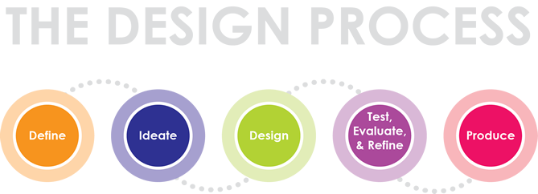

## **2.1 DEFINE PHASE**

### **2.1.2 USER RESEARCH AND ANALYSIS**

**Research Methods Used**:

* Surveys and Interviews: Conducted with potential users to understand their needs and challenges in emergency situations.
* **Competitive Analysis:** Evaluated existing emergency reporting apps like **Pulsepoint, FEMA App & Life360** to identify gaps and opportunities for improvement.

**Key Findings and Insights**:

* Users need a quick and intuitive way to report various types of emergencies.
* Real-time alerts are crucial for user safety.
* An integrated AI tool can provide immediate support and first aid instructions, reducing the response time in emergencies.

### **2.1.2 USER PERSONAS**

This outlines detailed profiles of the target users for the Resilix app, helping to understand their needs, goals, and behaviors. By identifying key personas such as an emergency reporter, a medical professional, and a community leader, the app can be tailored to meet their specific requirements and enhance user experience.

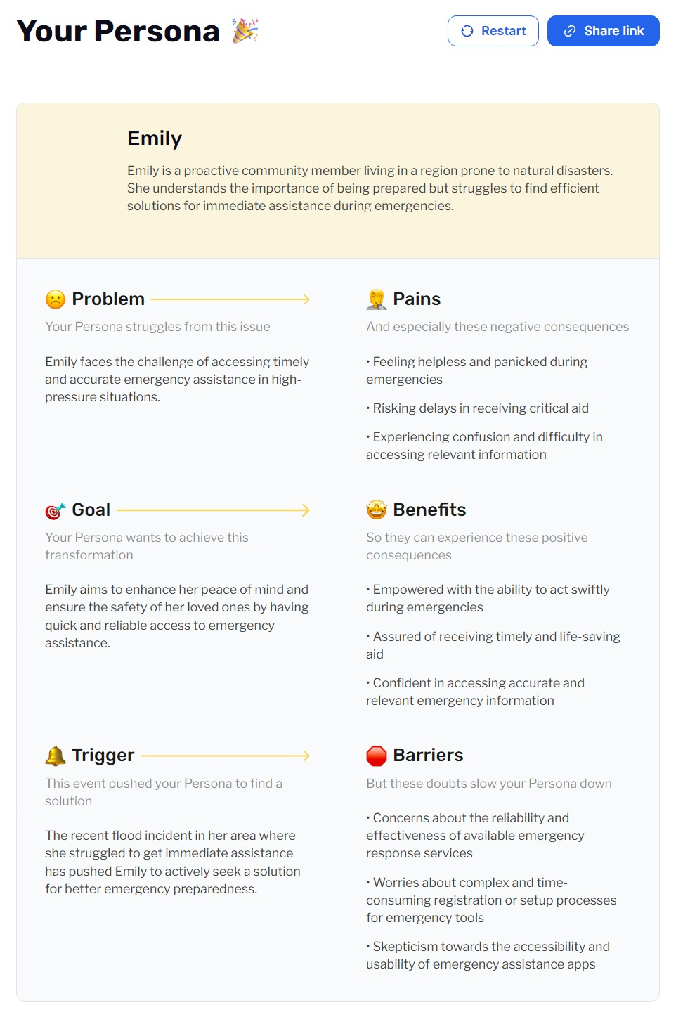

**Persona 1**: 🧑‍⚕️

* **Name**: Jane Etta
* **Age**: 28
* **Occupation**: Nurse
* **Needs**: Reliable tool for emergency reporting, first aid instructions, community alert system.
* **Pain Points**: Insufficient first aid knowledge, delayed emergency responses.

**Persona 2**: 🧑‍🚒

* **Name**: Michael Brown
* **Age**: 42
* **Occupation**: Firefighter
* **Needs**: Accurate emergency reports, real-time location information, coordination with community alerts.
* **Pain Points**: Inaccurate emergency location data, lack of coordination between community alerts and emergency response.

### **2.1.3 USER JOURNEY/USER FLOW**

The user flow diagram illustrates the key interactions a user will have with the Resilix app, from logging in to reporting emergencies and receiving real-time alerts. It includes decision points such as successful login, reporting different types of emergencies, interacting with the AI tool, and accessing settings.

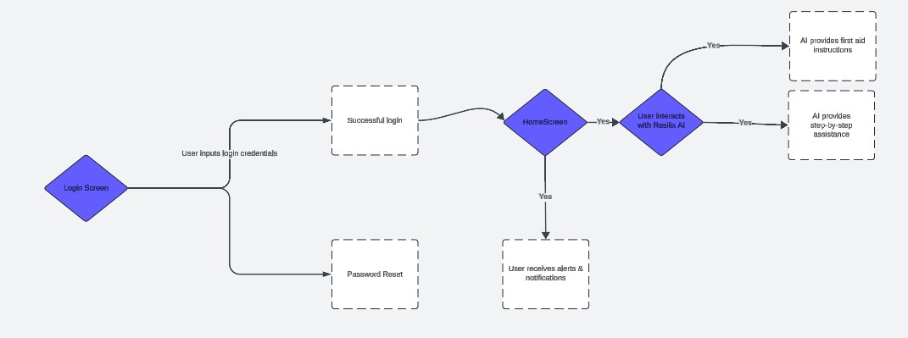

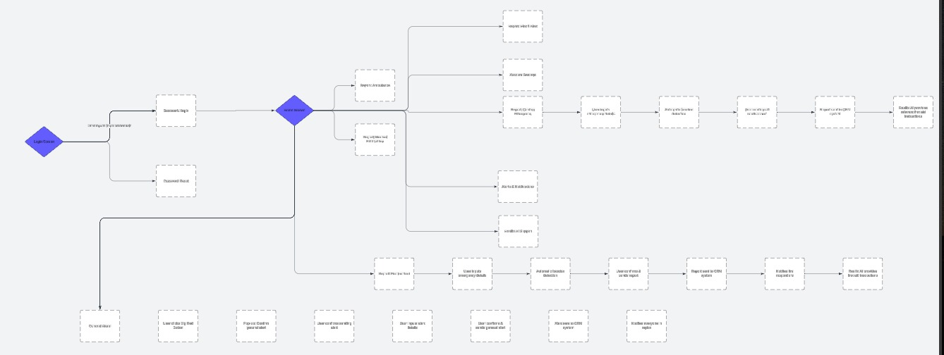

## **2.2 IDEATE**

### **2.2.1 BRAINSTORMING**

* **Techniques Used**: We utilized techniques such as sticky notes and brainstorming sessions with stakeholders to generate ideas for the Resilix app.
* **Key Ideas**: Focused on emergency reporting, real-time alerts, AI-based first aid, and community coordination features.

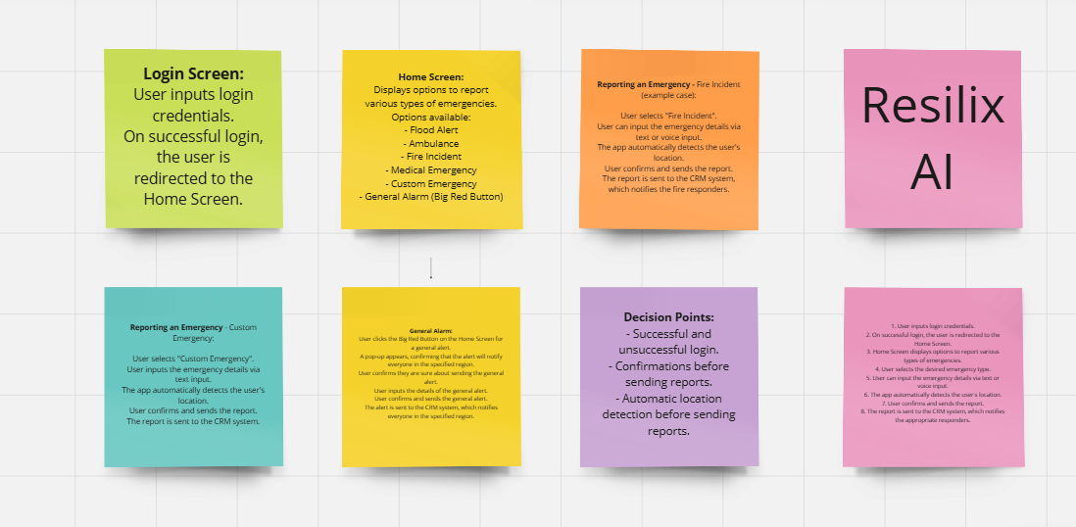

### **2.2.2 CONCEPT DEVELOPMENT**

* **Initial Concepts**: Developed initial concepts and sketches based on brainstorming sessions.
* **Evaluation**: Evaluated concepts against user needs and project goals to identify the most viable solutions.

### **2.2.3 ROUGH SKETCHING**

Drawing by hand is the fastest way to visualize a concept so it should always serve as your backup method.

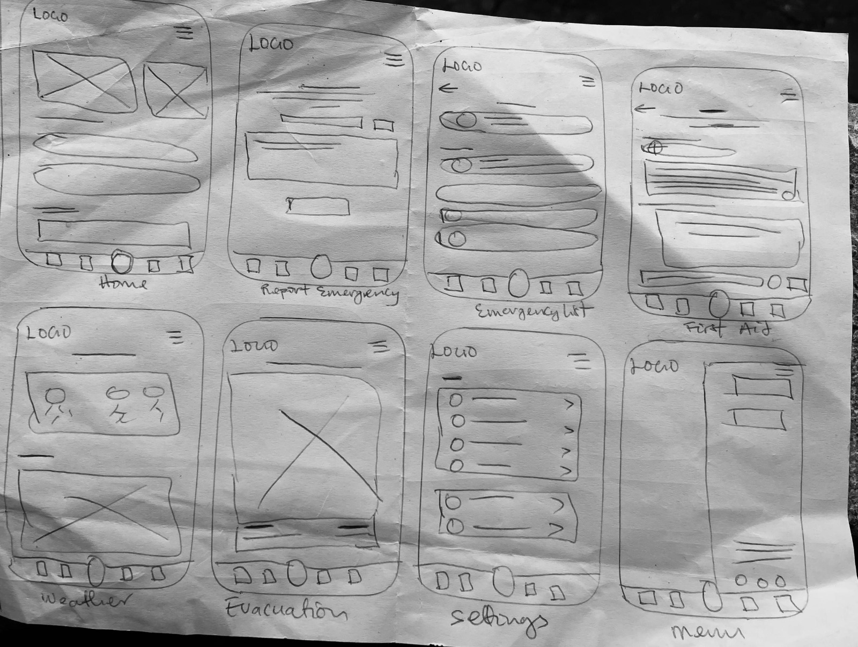

## **2.3 DESIGN PHASE**

### **2.3.1 WIREFRAMES:**

The wireframes provide a visual blueprint of the app's layout and structure, showcasing the placement of key elements such as emergency buttons, AI tool interface, and settings menu.

**DIGITAL WIREFRAMING**

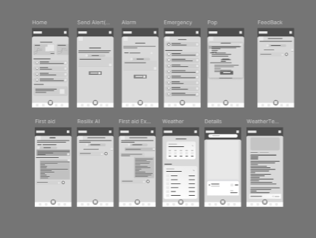

Low-fidelity wireframes are the most basic representations of the user interface. Then mid-fidelity, which offers more visual detail than low-fidelity. And finally, you have high-fidelity, which is the most detailed and visually polished representation of the user interface.

### **2.3.2 VISUAL DESIGN GUIDELINES AND STYLE GUIDE**

**Typography**:

* **Font Family**: Poppins
* **Font Weights and Styles**:
  + Light (300): Used for secondary text and hints.
  + Regular (400): Used for body text.
  + Medium (500): Used for primary buttons and labels.
  + Bold (700): Used for headings and subheadings.

**Color Scheme**:

* **Primary Colors**: Blue (#007bff), Red (#ff0000), White (#ffffff)
* **Secondary Colors**: Light Blue (#f0f8ff), Gray (#6c757d)

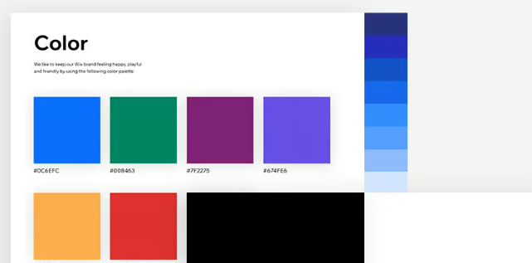

### **2.3.3 COLOR SCHEME**

* **Primary Color: Blue (#1D4ED8)**
  + **Reason**: Blue is often associated with trust, reliability, and safety, making it an ideal choice for an emergency response application. It instills confidence in users, assuring them that the information and services provided are trustworthy. The specific shade of blue used is also vibrant enough to catch attention without being overwhelming.
* **Secondary Color: Red (#EF4444)**
  + **Reason**: Red is universally recognized as a color for warnings and alerts. It is used to draw attention to critical areas of the application, such as emergency alerts and the "Send Alert" button. This helps in ensuring that users can quickly identify and respond to urgent situations.
* **Neutral Colors: Shades of Gray (#6B7280, #F3F4F6)**
  + **Reason**: Neutral colors like gray are used for backgrounds and secondary text to provide a balanced and clean look. They help in making the primary content stand out while maintaining a professional and uncluttered interface. The use of different shades allows for creating visual hierarchies and separating different sections effectively.

### **2.3.4 ICONS AND IMAGERY:**

* **Icon Style**: Simple, clean, and filled icons.
* **Usage**: Icons for emergencies (fire, flood, ambulance) and general actions (home, settings, send, back).

**Reason**: Line icons are used to maintain a clean and modern look. They are easy to recognize and understand, which is crucial in an emergency response app where quick comprehension is vital. The simplicity of line icons ensures that they do not distract from the primary content and functionality of the app.

**Imagery**

* **Style**: Realistic and context-specific images
* **Reason**: Realistic images are used in scenarios where visual context is necessary, such as depicting different types of emergencies. This helps users quickly identify the type of emergency they are dealing with. Context-specific images enhance user engagement and understanding of the app’s features.

**Interaction Design**:

* **Buttons**: Rounded corners, with blue for primary actions and red for critical actions.
* **Input Fields**: Rounded corners, clear labels and placeholders, validation messages in red.
* **Pop-ups and Modals**: Semi-transparent background, prominent action buttons.
* **Navigation**: Bottom navigation bar with icons and labels for Home, Emergency, AI Assistant, and Settings.

**Microinteractions**:

* **Button Press**: Color change and shadow effect.
* **Loading Indicators**: Spinners or progress bars.
* **Error Messages**: Clear, concise, near the element causing the error.

## **2.4 REFINE PHASE**

### **2.4.1 PROTOTYPING: High-Fidelity Prototype:**

The high-fidelity prototype presents the polished visual appearance of the app, highlighting the color scheme, typography, and iconography used to create an intuitive and aesthetically pleasing interface. Screens include the home screen, emergency reporting screen, and general alert screen.

### **2.4.2 UI MOCKUPS**

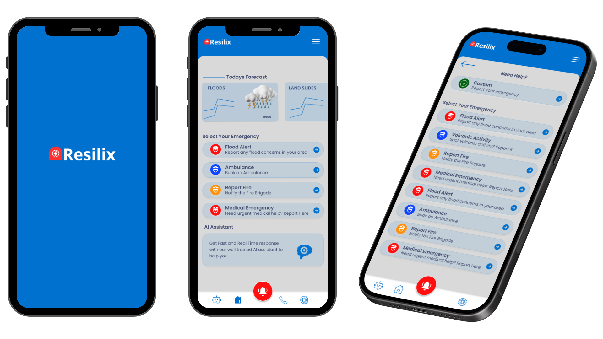

Includes placement of primary and secondary buttons, labels, and placeholders & Shows the final layout with color schemes, typography, and icons.

### **2.4.3 ITERATIVE FEEDBACK AND IMPROVEMENTS**

**User Feedback**: Collected feedback from initial prototype testing sessions within the team stakeholders, external stakeholders and potential users.

**Improvements**: Adjusted design elements based on user feedback, improved navigation flow, and refined visual elements for better usability.

## **2.5 SCREENS & VIEWS**

Figma link to UI design : [Resilix UI](https://www.figma.com/design/DbGJJGrbx3wVOCA0TQ28T7/Resilix-(Copy)?node-id=207-33&t=58Kgdj60pOE3zibm-1)

### **2.5.1 SCREEN DESCRIPTIONS**

1. **Welcome Screen:**
   * **Purpose:** Initial entry point of the app to greet users and set the tone.
   * **Components:** App logo, app name (Resilix).
   * **User Flow:** Users are introduced to the app with branding before proceeding to login or sign up.
2. **Login Screen:**
   * **Purpose:** To allow existing users to access their accounts.
   * **Components:** Fields for email and password, login button, options for Google sign-in, and a link to the registration page.
   * **User Flow:** Users enter their credentials and log in, or opt to sign in with Google.

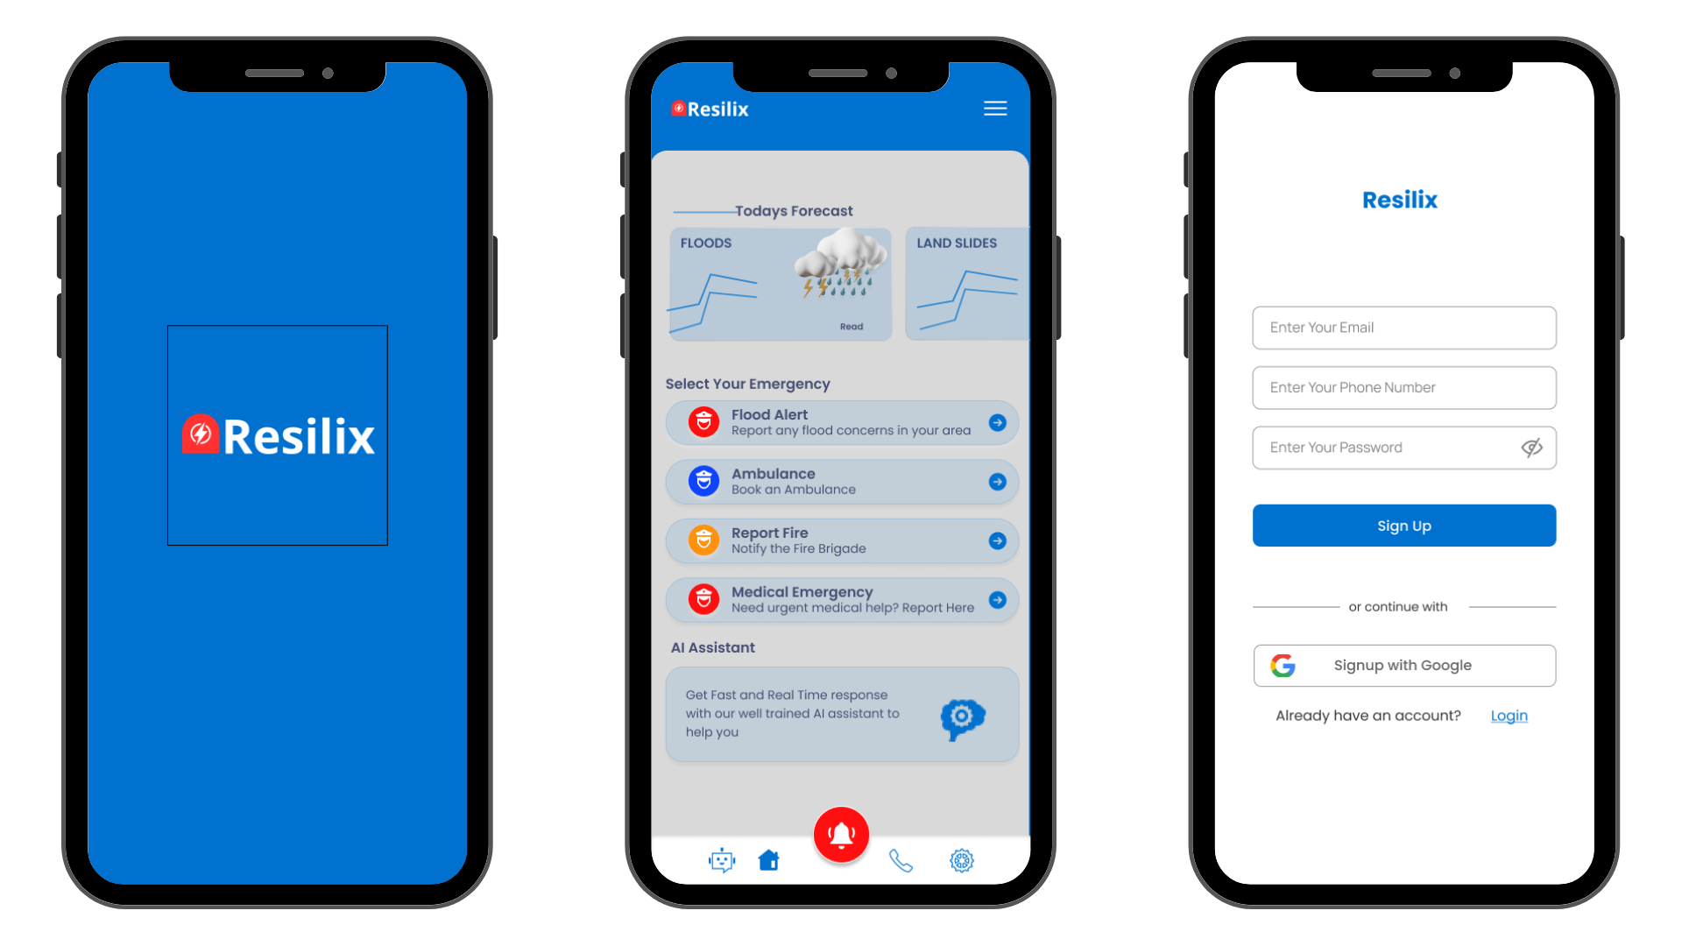

1. **Registration Screen:**
   * **Purpose:** To enable new users to create an account.
   * **Components:** Fields for name, email, password, sign up button, and Google sign-up option.
   * **User Flow:** New users fill in the details to create an account or sign up using Google.
2. **Home Screen:**
   * **Purpose:** The central hub where users can view forecasts, select emergencies to report, and access other functionalities.
   * **Components:** Weather forecast, emergency options (Flood Alert, Ambulance, Report Fire, Medical Emergency), and AI Assistant access.
   * **User Flow:** Users can view weather forecasts, choose an emergency to report, or interact with the AI Assistant from here.

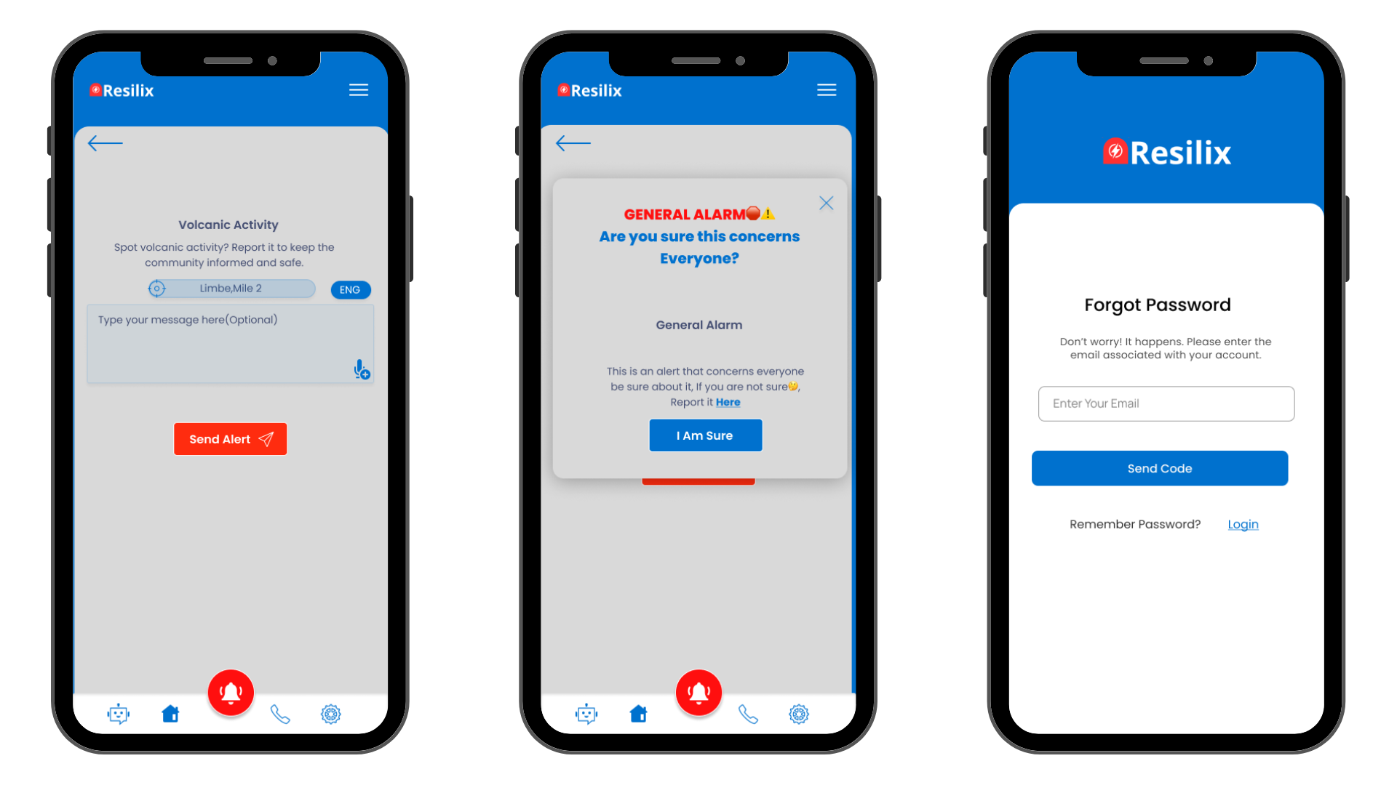

1. **General Alarm Confirmation Screen:**
   * **Purpose:** To confirm if the user wants to send a general alert.
   * **Components:** Confirmation message, "I Am Sure" button.
   * **User Flow:** Users confirm the action to send a general alert that concerns everyone.
2. **Forgot Password Screen:**
   * **Purpose:** To help users recover their accounts.
   * **Components:** Email input field, send reset link button.
   * **User Flow:** Users enter their email to receive a password reset link.

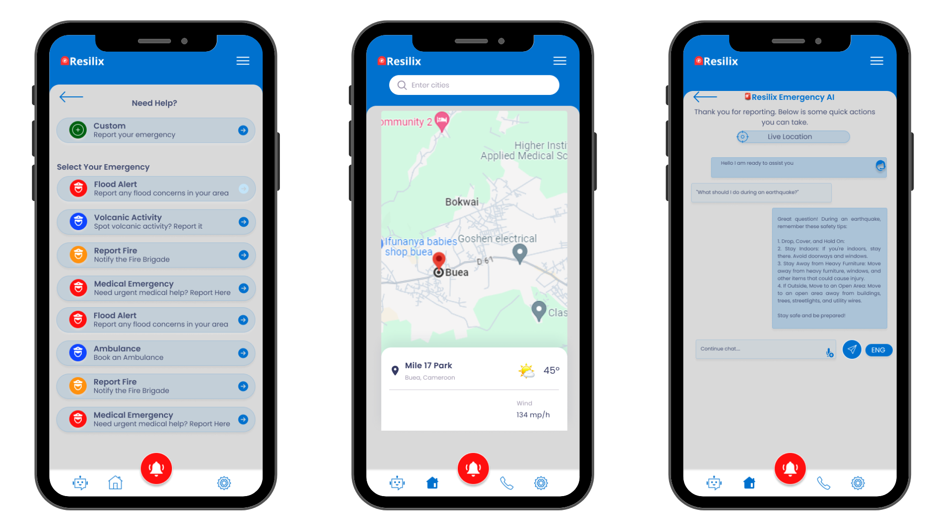

1. **Emergency Selection Screen:**
   * **Purpose:** To list all available emergency types for reporting.
   * **Components:** List of emergencies (Flood Alert, Ambulance, Report Fire, Medical Emergency, etc.).
   * **User Flow:** Users select the type of emergency they need to report.
2. **Custom Emergency Report Screen:**
   * **Purpose:** To allow users to report emergencies not listed in predefined options.
   * **Components:** Text input for emergency details, location auto-detection, and send alert button.
   * **User Flow:** Users type in the details of their custom emergency and send the alert.
3. **Weather Forecast Detail Screen:**
   * **Purpose:** To provide detailed weather forecasts.
   * **Components:** Weather information for multiple days, detailed weather predictions.
   * **User Flow:** Users can view detailed weather forecasts.
4. **Emergency Details Screen:**
   * **Purpose:** To provide detailed information about a specific emergency.
   * **Components:** Emergency details, map showing the affected area.
   * **User Flow:** Users can view the details of the reported emergency and see the location on a map.
5. **Descension Route Screen:**
   * **Purpose:** To show evacuation routes during emergencies.
   * **Components:** Map with highlighted evacuation routes.
6. **AI Assistant Interaction Screen:**
   * **Purpose:** To provide users with immediate assistance through AI.
   * **Components:** Chat interface with AI assistant, options for various types of assistance.
   * **User Flow:** Users can ask for help and receive automated responses or instructions from the AI assistant.

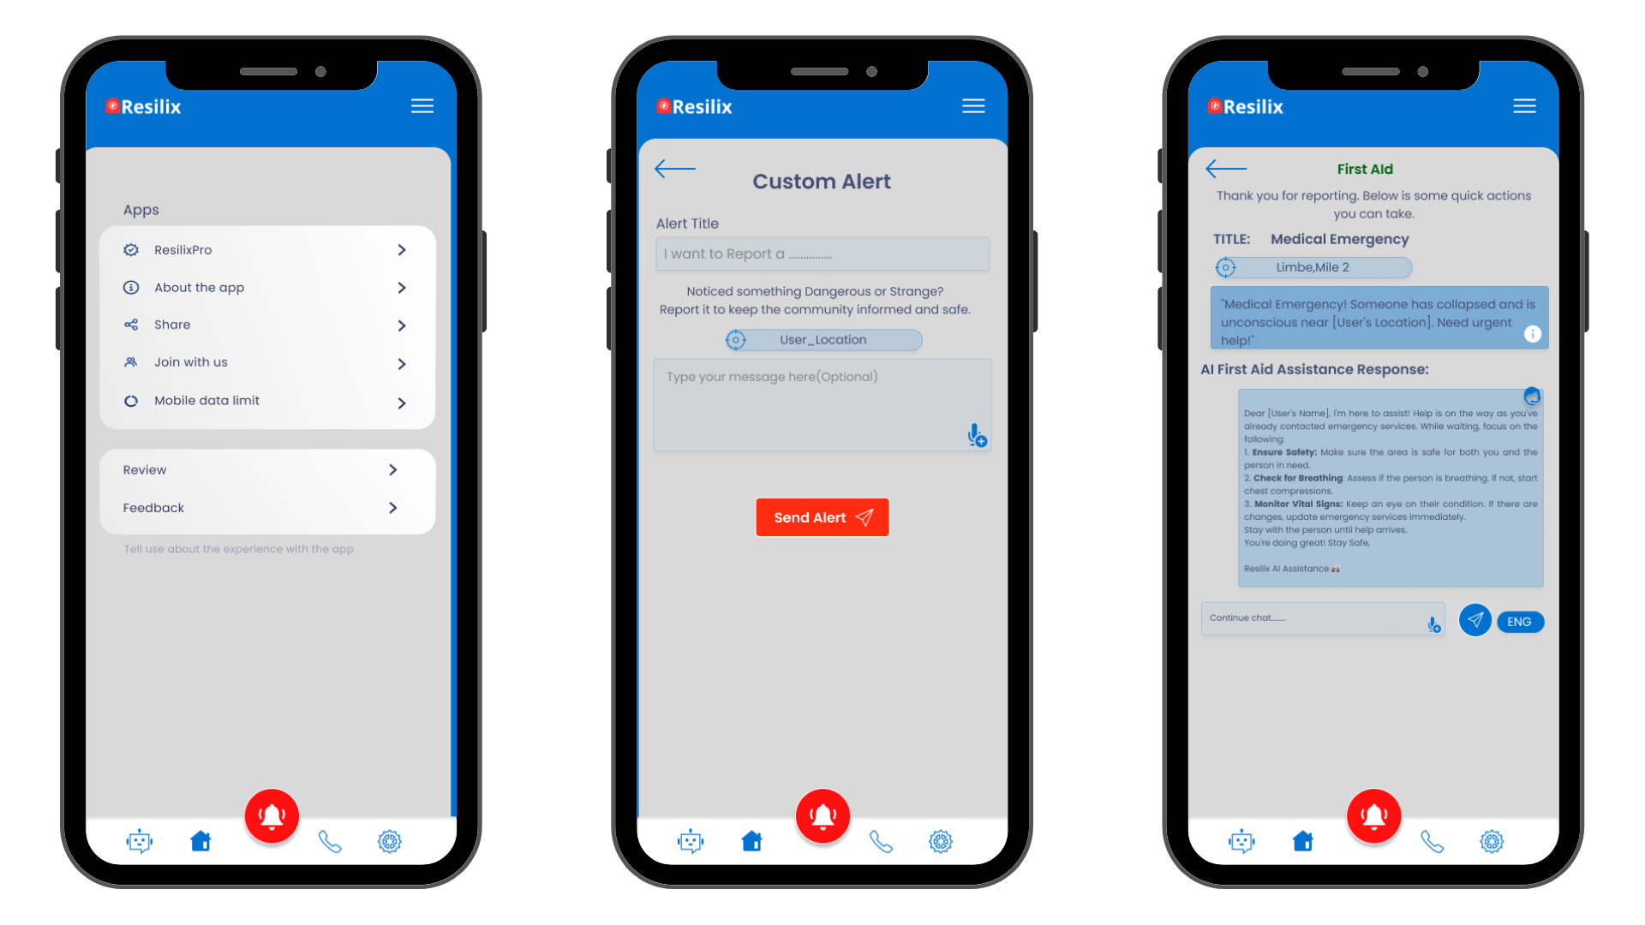

1. **Settings Screen:**
   * **Purpose:** To allow users to manage their account settings.
   * **Components:** Options for changing account information, preferences, and app settings.
   * **User Flow:** Users can update their account information and customize their app experience.
2. **Custom Alert Input Screen:**
   * **Purpose:** To enable users to send custom alerts.
   * **Components:** Text input for custom alert details, location auto-detection, send alert button.
   * **User Flow:** Users enter details about their custom alert and send it.

## **2.6 DETAILED USER FLOW(SCREEN FLOW)**

1. **Login:**
   * Users start at the **Welcome Screen** and proceed to the **Login Screen**.
   * They log in using their credentials or sign up if they don't have an account.
2. **Home Navigation:**
   * Once logged in, users reach the **Home Screen** where they can view weather forecasts and select emergency types to report.
3. **Reporting an Emergency:**
   * Users can choose from predefined emergencies (e.g., Fire, Flood) or create a **Custom Emergency Report**.
   * They can also use the **Volcanic Activity Report Screen** for specific incidents.
4. **Sending Alerts:**
   * For a general alert, users are prompted with the **General Alarm Confirmation Screen**.
   * For specific emergencies, users fill in details and send the alert through the appropriate reporting screen.
5. **AI Assistance:**
   * Users can interact with the AI assistant from the **Home Screen** or the **AI Assistant Interaction Screen** for immediate help.
6. **Additional Features:**
   * Users can view detailed weather forecasts on the **Weather Forecast Detail Screen**.
   * They can check evacuation routes on the **Descention Route Screen**.
   * Manage settings and account details from the **Settings Screen**

## **2.7 TEST PHASE**

### **2.7.1 USABILITY TESTING**

* **Methodology**: Conducted usability testing sessions with stakeholders to assess the app’s functionality and user experience.
* **Key Findings**:
  + We found the emergency reporting process intuitive and quick.
  + The AI tool provided helpful first aid instructions.
  + Real-time alerts were effective in keeping users informed.
* **Adjustments Made**: Based on feedback, refined the placement of some elements, improved error messaging, and enhanced the accessibility features.

### **2.7.2 ACCESSIBILITY CONSIDERATIONS**

**Color Contrast**: Ensure sufficient contrast between text and background colors (minimum 4.5:1 ratio).

**Text Size**: Minimum font size of 14px for readability.

**Touch Targets**: Minimum 44x44 pixels for touch targets to ensure they are easily tappable.

**Alternative Text**: All images and icons have descriptive alt text for screen readers.

**Keyboard Navigation**: Ensure all interactive elements can be accessed via keyboard.

## **2.8 CONCLUSION**

The Resilix app aims to provide a reliable and user-friendly platform for emergency reporting and real-time alerts. By adhering to our detailed design guidelines and user-centered approach, we ensure that the app meets the needs of our target audience while providing an intuitive and accessible experience. Our comprehensive wireframes, prototypes, and visual design standards serve as the foundation for delivering a high-quality application that enhances community safety and responsiveness.